Ideation Phase
Brainstorm & Idea Prioritization Template
Date | 01 Nov 2025
Team ID | NM2025TMID01600
Project Name | Laptop Request Catalog Item
Maximum Marks | 4 Marks

Laptop Request Catalog Item Template:
This guided project focuses on automating the process of requesting laptops within an organization using the ServiceNow platform. The goal is to streamline the approval and fulfillment process, ensuring transparency and efficiency.Employees can request laptops through a user-friendly catalog form. The form includes required fields such as laptop model, purpose, and accessories. UI Policies are applied to simplify the form dynamically, while approval workflows ensure that each request is validated by the appropriate manager. Finally, the IT team fulfills the approved requests and updates the request status automatically.This project minimizes manual communication, improves service delivery time, and enhances accountability between employees, managers, and IT teams.
Step-1: Team Gathering, Collaboration and Problem Identification:
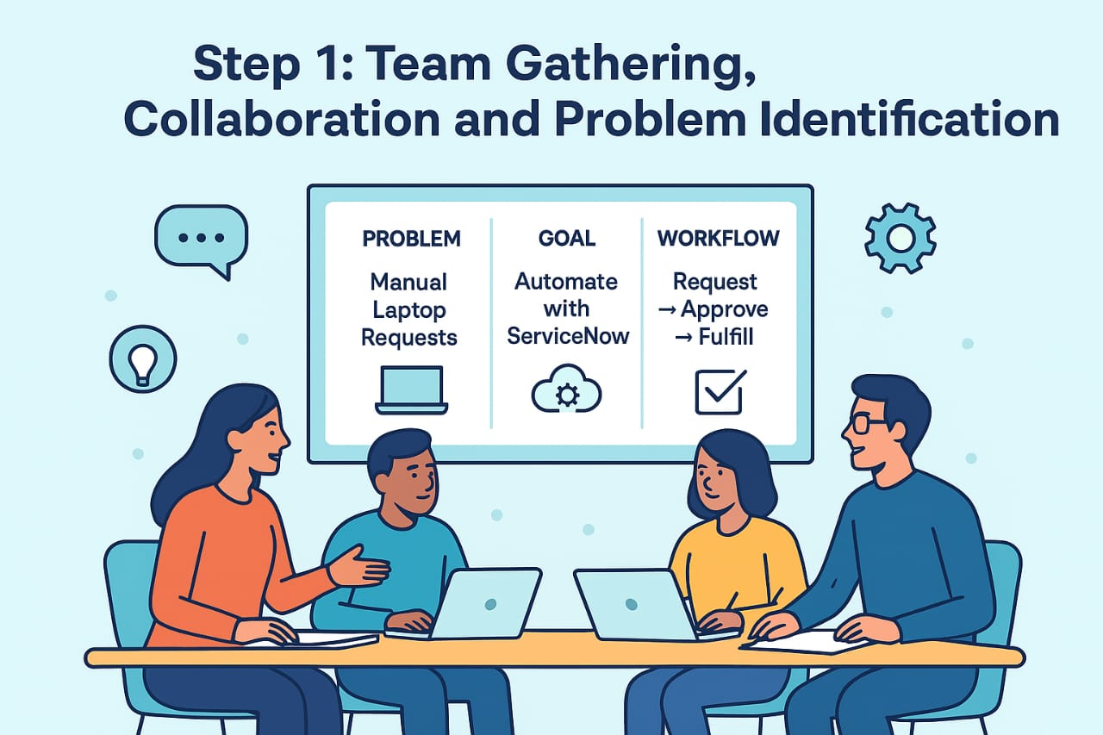

Step-2: Brainstorm, Idea Listing and Grouping:
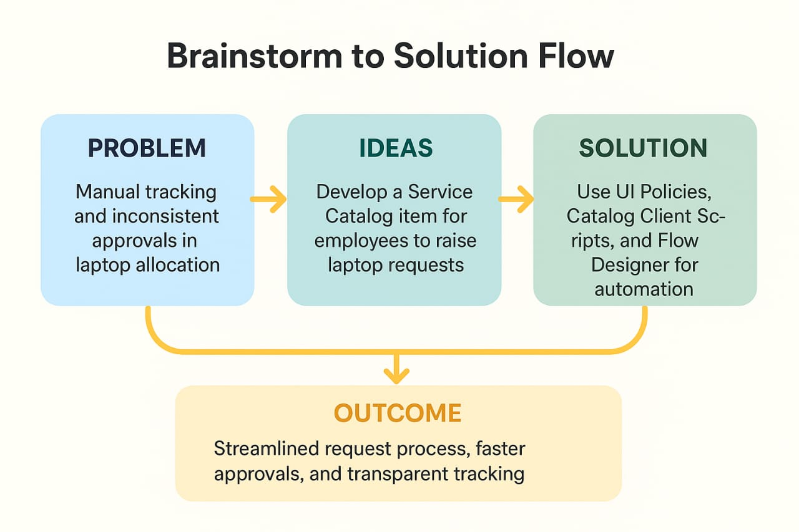
Brainstorm:
Team members shared ideas on how to automate request creation, apply dynamic validation, and integrate workflow approvals.
Idea Listing:
Create laptop request catalog item.Add dynamic variables (Laptop model, Justification).Set UI policies for field visibility.
Grouping:
Grouped ideas under — Form Design, Automation, Notifications, and Fulfillment.
Action Planning:
Form design, approval workflow, notification & testing

Step-3: Idea Prioritization:

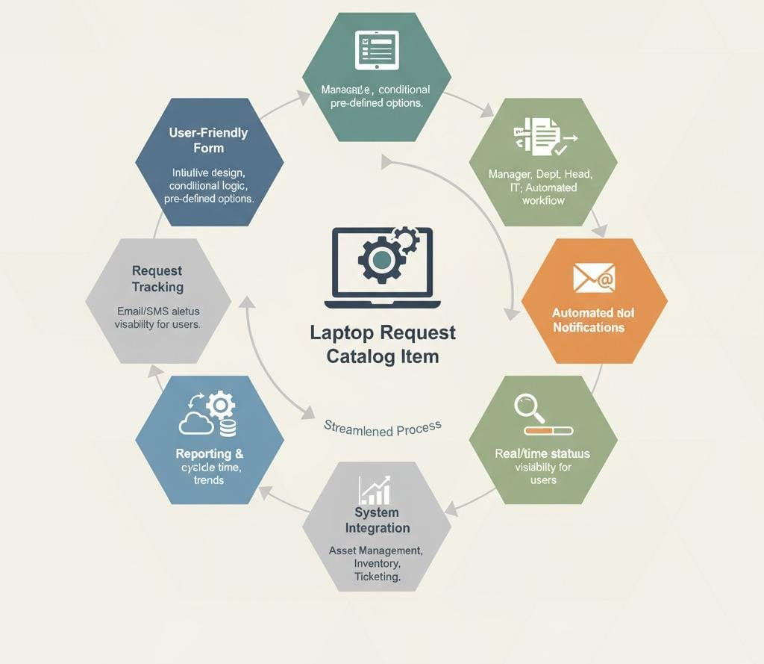

Idea Prioritization:
The prioritization helped the team identify the most impactful features to develop first — the form creation and approval automation. This structured approach enhanced project focus, ensuring that high-value ideas were implemented effectively to improve user satisfaction and IT efficiency.

